Objective
The overall objective of this lab is to configure BGP routing between two routers so that there is a routed BGP network connection between computers in the two LANs. You configure the network topology and the IP addresses for the appropriate router interfaces. This requires that the serial connection between routers be configured and enabled.
Lab Submission
On a Word Document, write all the steps and commands you took to answer Task #1.
Topology
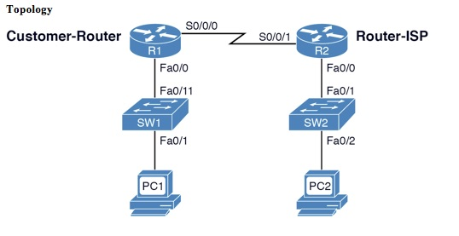
Figure 1: The Network Topology for This Lab
Reference Tables
For convenience, Table 1 provides the IP address and mask of all necessary interfaces used to complete the lab.
Table 1: The Computer IP Addresses, Subnet Masks, and Gateway Addresses
Computer/Interface – R1 | IP Address | Subnet Mask | Gateway Address
PC1 | 10.10.12.1 | 255.255.255.0 | 10.10.12.250
R1-Fa0/0 | 10.10.12.250 | 255.255.255.0 | ------------------
R1-S0/0/0 | 172.16.25.1 | 255.255.255.252 | ------------------
Computer/Interface – R2 | IP Address | Subnet Mask | Gateway Address
PC2 | 10.10.30.65 | 255.255.255.0 | 10.10.30.250
R2-Fa0/0 | 10.10.30.250 | 255.255.255.0 | ------------------
R2-S0/0/1 | 172.16.25.2 | 255.255.255.252 | ------------------
Detailed Lab Steps
In the following tasks, you must demonstrate your knowledge to configure computer networks. Each task specifies a particular network setting you are required to input. You are required to document the command(s) used to accomplish each task.
Task # 1
In this lab, you configure BGP from the Customer-Router to the ISP Router [Router-ISP] based on the network topology provided in Figure 1. You use the IP addresses provided in Table 1. You will be asked to verify that computers in your LAN can ping the neighbor LAN. You are configuring BGP routing for 10.10.12.0/24, 10.10.30.0/24, and 172.16.25.0/30 networks. Note that a serial interface is used to interconnect the LANs. Use 56000 for the clock rate on the serial link (DCE interface). The enable secret and line console 0 password should be set to ciscopress.
- Configure the gateway address for your LAN routers according to the addresses listed in Table 1. List the prompt and the command used to configure the gateway address and subnet mask on each of the routers.
- Configure the hostname for your routers; R1 should be renamed the Customer-Router and R2 should be renamed Router-ISP. List the router prompt and command used to configure the router’s hostname.
- Configure the router IP addresses and subnet masks for both the serial interfaces on both routers. You also need to enable the serial interfaces. Use the proper command to verify that the interfaces are properly configured. List the router prompt and commands used to accomplish this task. Also, use the command to verify the interfaces are properly configured.
- Enable BGP routing on the Customer-router using an AS number of 65000. Advertise the 10.10.12.0 network to its BGP peers. Use the command to specify the IP address of the BGP neighbor. Use the command to specify this is the ISP BGP Connection.
- Enable BGP routing on Router-ISP using an AS number of 65001. Advertise the 10.10.30.0 network to its BGP peers. Use the command to specify the IP address of the BGP neighbor. Use the command to specify this is the Customer BGP Connection.
- Use the ping command to verify that you have the customer ping the ISP using the IP address provided by the ISP.
- Use the proper command to verify the routers are exchanging routes. How do you know the routers are exchanging routes?
- Use the computers in each LAN to ping the computers in the adjacent LAN, PC1-PC2, and PC2-PC1. List the router prompt and command used to accomplish this.
- Use the proper command to trace the route from a PC in LAN-A to a host in the LAN-B. Your trace should pass through two routers. List the router prompt and command used, and record the trace information. How may hops did you record?
- Use the command to make a telnet connection from the LAN-A router to the LAN-B router. Set the VTY password to ciscopress on the LAN-B router and enable remote login. List the prompts and the commands used to establish the Telnet connection. What IP address did you use? Repeat this so that a Telnet connection is established from the LAN-B router to the LAN-A router.
- Use the router command that lists the network routes stored in the LAN-A router’s routing table. List the prompt, the command used, and the available routes. Are all the routes defined for your network? What does it mean to say that the “Gateway of last resort is not set” ?
- Use the command to save your router configuration to the startup configuration on the LAN-A router. What command did you use? Use the proper command to verify the configuration has been saved to NVRAM. What command did you use?

